EMPOWER – Editor User Documentation

Setup/Install 2

Standalone 2

Installer 2

Splash Screen 3

Controls 3

Map Screen 4

Controls 4

Screen Layout 4

Map Menu 5

Event Creation 7

Controls 7

Screen Layout 7

Walkthrough 8

Cards 9

Event 10

Action 11

Consequence 12

Information 13

Character 14

Information 14

Image Management 15

Information 15

Background Setup 16

Information 16

Tutorial Setup 17

Information 17

Options 18

Information 18

Custom Stats 19

Information 19

# Setup/Install

## Standalone

If you are using the standalone exe, simply double click the icon to open the application.

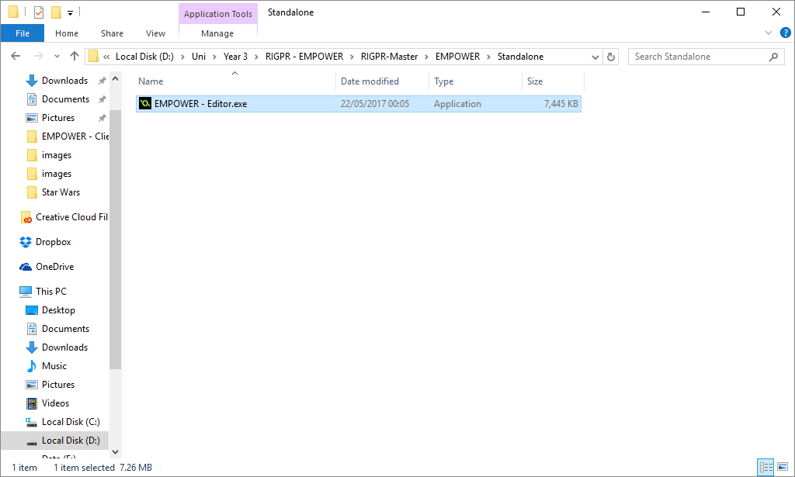

## Installer

If you are using the installer, double click the icon and you will be presented with the install window, this will require you to agree to the License Agreement and select an install location; other options such as start menu and desktop shortcuts are also offered. If you follow the prompts from the installation window, it should explain what is required at each step.

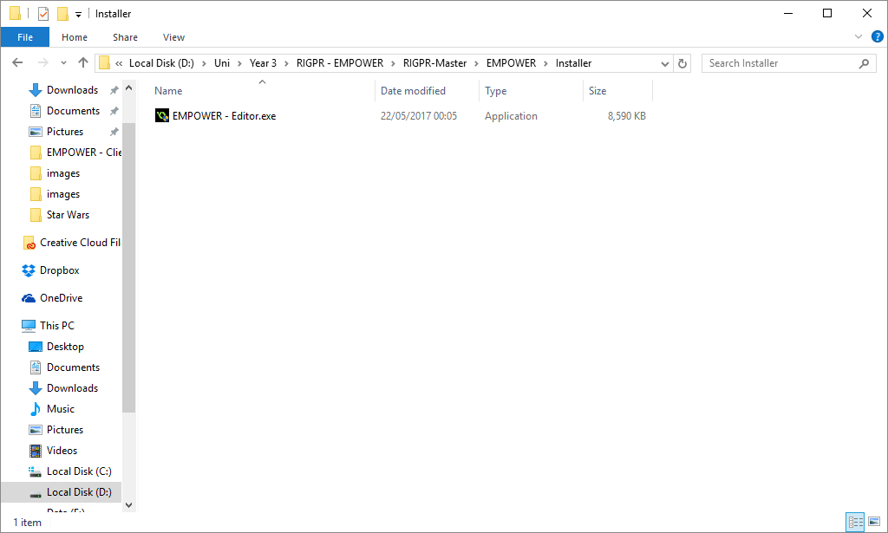

Once the process has completed, select the shortcut (either start menu or desktop, if you selected this option) or navigate to the install location to begin.

# Splash Screen

## Controls

Left Mouse Button - Accept/Select

Once open, you will be presented with a splash screen, click anywhere to begin, you will be taken to the map screen.

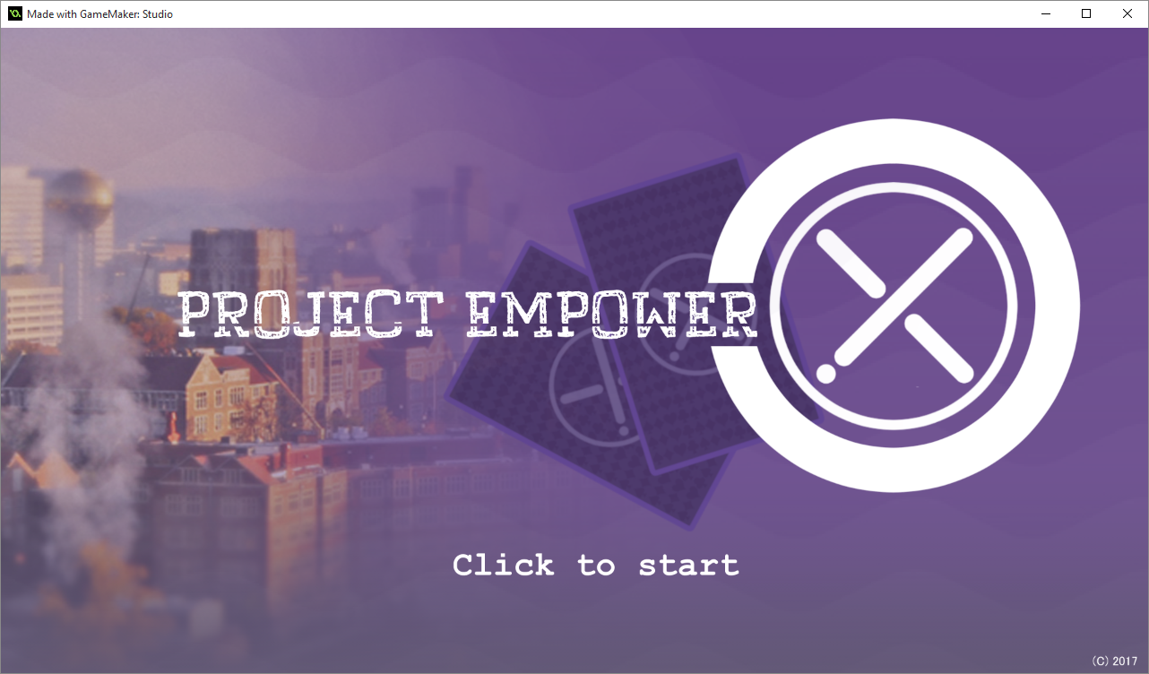

# Map Screen

## Controls

* Left Mouse Button – Accept/Select/Drag Map
* Right Mouse Button – Add Location (Editor Mode Only)
* Scroll Wheel Up – Zoom In
* Scroll Wheel Down – Zoom Out

On the Map Screen, you can use the Left Mouse Button to select buttons displayed on the screen. Clicking and holding the button on the Maps background, will allow you to drag the mouse and move the map.

You can use the scroll wheel to zoom in/out.

Inside Editor Mode, you can use the Right Mouse Button to add new locations.

## Screen Layout

1. This displays the current week/year, this is used to visit any week throughout the year and view what events are available on a given week.
2. These arrows are used to select the current week/year, the top arrow will change the year and the bottom arrow will change the week.
3. This list is a list of buttons that can be selected, I will be going over the buttons in the next sections of the guide.
4. This button opens the Character screen.
5. Editor Mode Banner.
6. Location Icon, this displays current locations you have added to the Map screen.

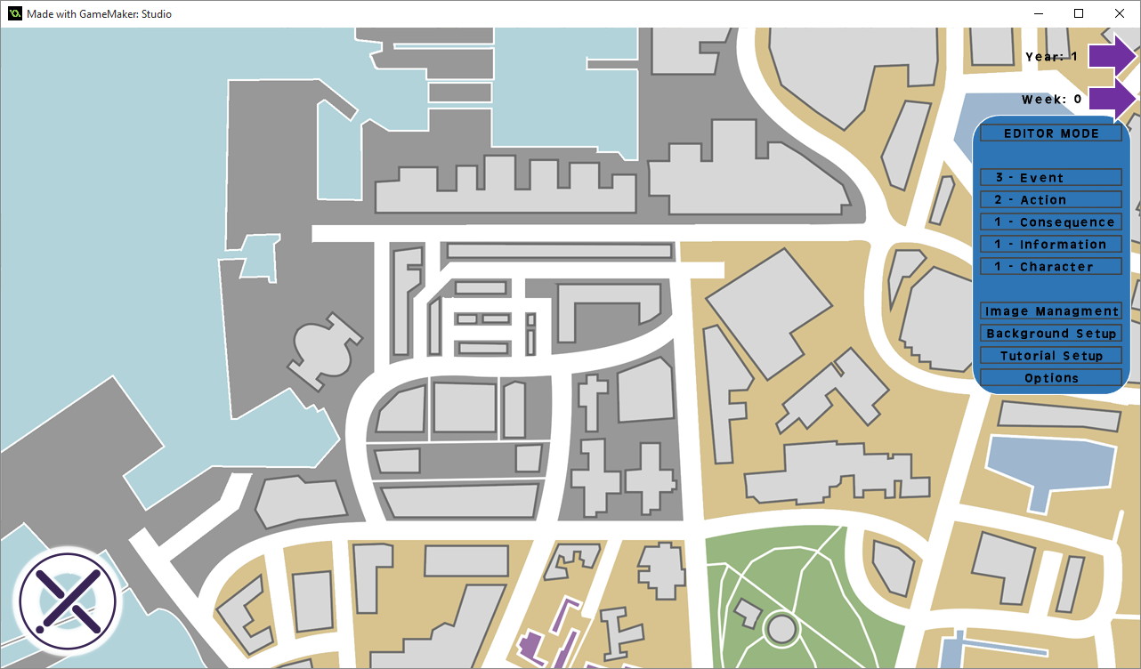

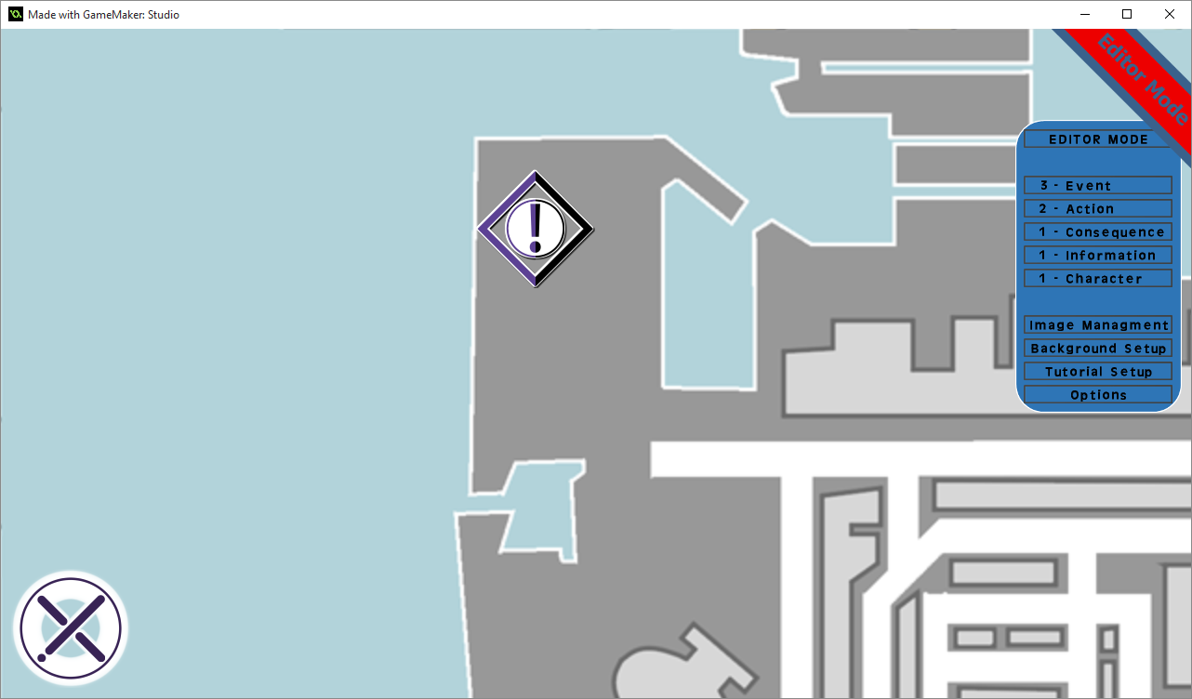

6.

5.

3.

4.

2.

1.

## Map Menu

### 4a - Editor Mode



4a.

Clicking the button highlighted above will enter the editor into *Editor Mode*. To indicate this, a banner will display in the top right corner of the screen which replaces the current week/year information. *Editor Mode* is primarily used to add new locations to the map, in this mode, ALL locations will be visible not just the currently selected week.

You can also use Right Click to add a new location to the Map screen, this will then allow you to select it by Clicking on the icon using Left Click. Once open, it will open the Event Creation Screen, please see *Page 10* for further information.

### 4b – Buttons



4b.

These buttons will take you to a new screen. I will give a brief description of each screen along with the section/page number for further infromation below.

* Event Card – Event Cards Deck and Editor, here you can View the all Event Cards that have been created, add new cards and edit already existing cards.
  + Requires: Action Cards, an Information Card and a Character Card.
  + Page:
* Action Card – Action Cards Deck and Editor, like the Event Cards, you can view, add and edit Action Cards.
  + Requires: A Consequence Card and an Information Card.
  + Page:
* Consequence Card – Add, View and Edit Consequence Cards.
  + Requires: An Information Card.
  + Page:
* Information Card – Add, View and Edit Information Cards.
  + Requires: None.
  + Page:
* Character Card – Add, View and Edit Character Cards.
  + Requires: An Information Card.
  + Page:
* Image Management – This screen allows you to view, add and delete images that can be added in other screens. These include, Card Art (images shown on cards), Card Backgrounds (the actual card image) and location images (the icons used on the map).
  + Page:
* Background Setup – This screen, similarly to Image Management, allows you to view, add and delete backgrounds from pages used within the client and editor.
  + Page:
* Tutorial Setup – This screen allows you to view/edit the custom location/cards created for the tutorial and remove tutorial segments as required.
  + Page:
* Options – This screen holds general options for the editor you are using, but also allows you to perform a few actions related to the game you are creating.
  + Page:

# Event Creation

## Controls

* Left Click – Select/Accept

## Screen Layout

1. Locations Info
   1. Name – Locations Name
   2. Description – Info about the location that will be displayed when the area is opened by the user
   3. Event Type – Displays what event type the Location will be, this is based on Mythical status of the Event held by the Location.
   4. Number of events – The number of events held by the location.
2. Events
   1. Events Info – This section displays the current events Info; arrows will display that can be used to select different events.
      1. You can enter the week/year for the current event.
      2. Displays the Event’s Mythical status type.
   2. Displays all events on the current week, you can only have 3 events on any week, this allows you to view all events on the current week.
   3. This button adds new blank events to the Location.
   4. Delete the currently selected event from the location.
   5. Select an Event Card to use in a Location’s Event slot.
3. Building Image
   1. This is the current icon that is displayed on the location. There can be 3 variants of icons, Normal, Mythical and Both, on any given week, depending on the held events, the correct icon will display on the map.
   2. Add a new Building Image, this requires 3 Images, one for each map variant and must be 128x128. Please follow the in game prompts.
   3. Deletes the current building image.
4. Background
   1. Adds a new Background image for the location (1920x1080 or 1280x720). Please follow the in game prompts.
   2. Arrows here can be used to select a background from the list of backgrounds.
5. Delete Location - Deletes the current Location and returns you to the map.
6. Back - Saves the Location and returns you to the map. The Back button will display on most pages allowing you to return to the previous screen.

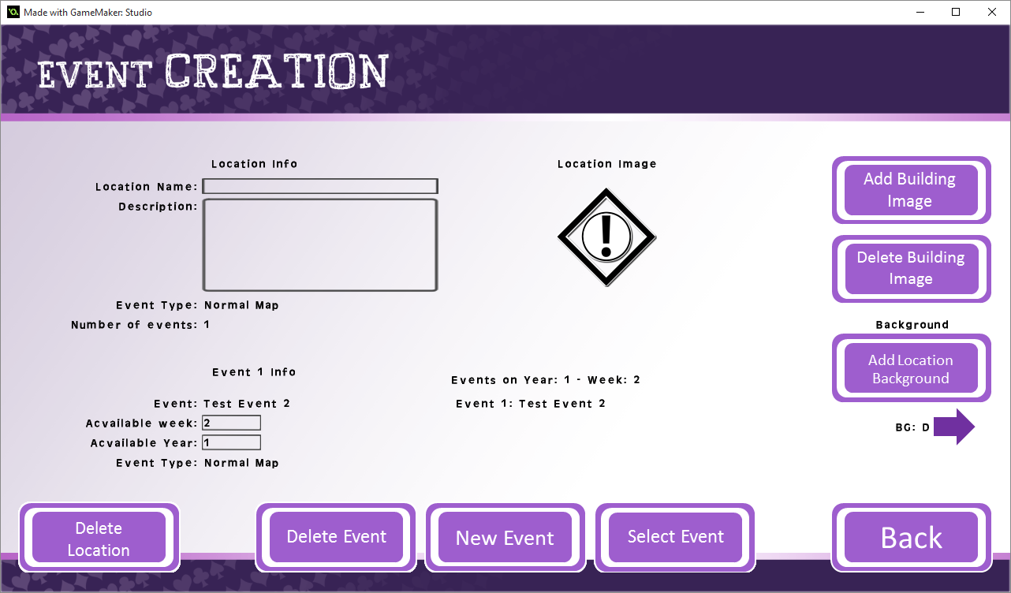

3b.

3a.

3c.

4a.

4b.

6.

2b.

2e.

2c.

2d.

5.

2a.

1.

## Walkthrough

* When you first access a Location, it will be fairly blank, you can enter the text info as required.
* If you click “New Event”, a new blank event will be created.

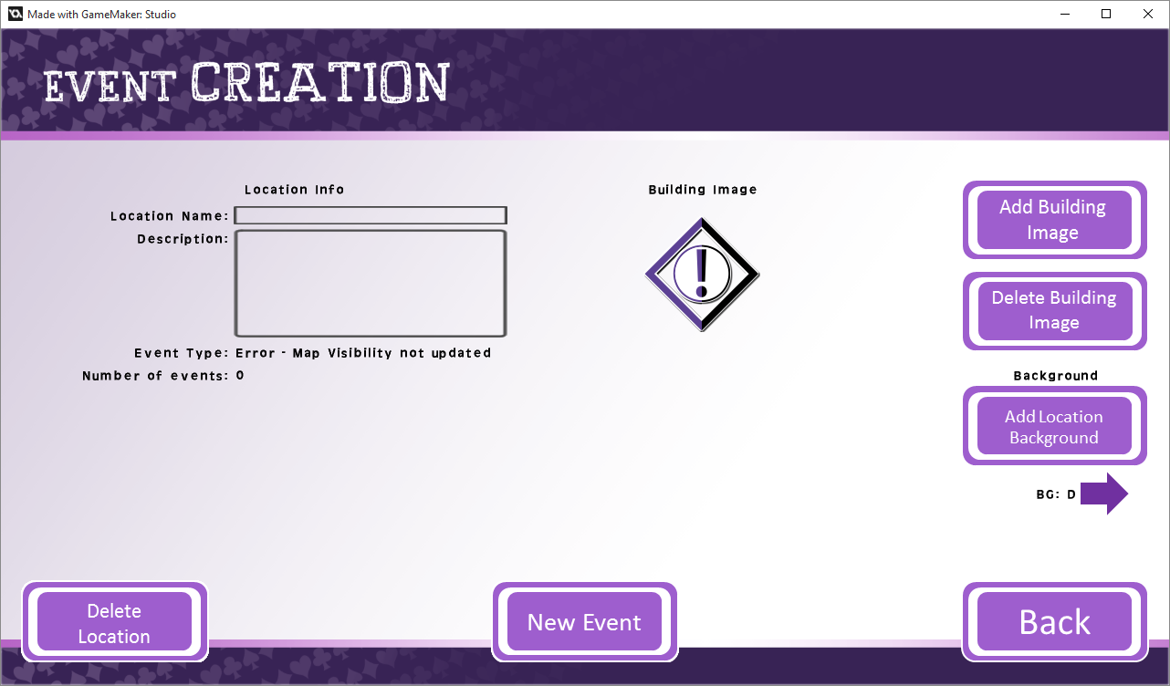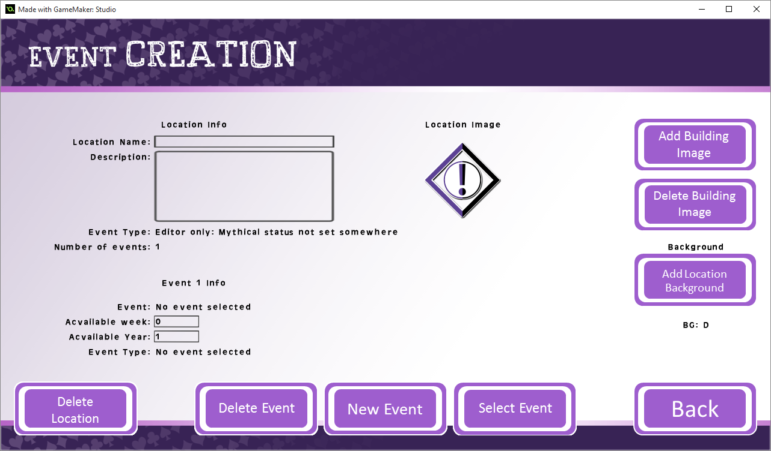

* 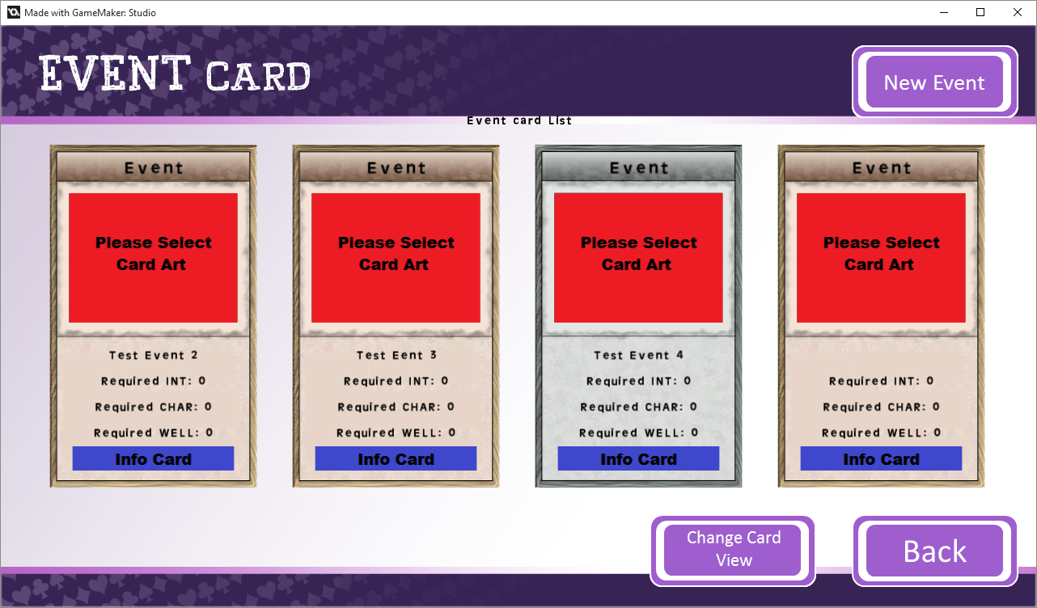After creating an event, the Delete and Select Event buttons will appear. Using the select Event button will open the Event Cards Deck Screen.
* On this screen, simply click the event card you wish to select and it will fill the blank slot.

# Cards

### Controls

* Left Click – Select/Accept

### Screen Layout

1. New Event/Card – This button adds a new card to the current deck, you will be taken to the current decks card creation, each card has different attributes and will be covered in the next sections of this document.
2. Change Card View – This changes the current view from the Cards with as they are displayed (3a.) and the List view displaying a list of text boxes (3b.).
3. Card
   1. Card as selection, clicking this will allow you to edit the card.
   2. Card in a list, clicking this will also allow you to edit the card.
   3. Please note that 3a and 3b are the same card.



3a.

1.

2.

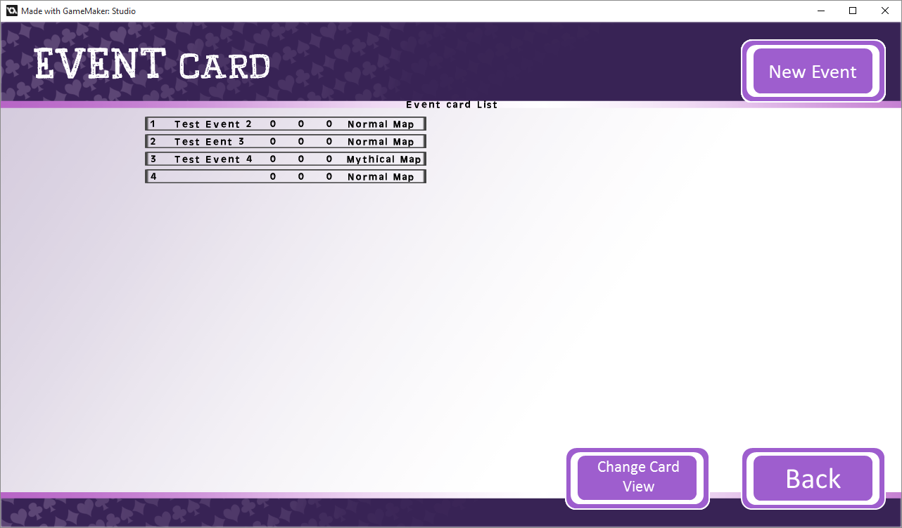

3b.

## Event

### Controls

* Left Click – Select/Accept

### Screen Layout

1. Card Type
   1. Card Type Title.
   2. Card Type on the Card.
2. Event Attributes
   1. Name + Stat Entry.
   2. Name + Stat Display on the Card.
3. Event Type
   1. Display of Event Type (Mythical or Regular).
   2. Event Type button. Clicking this will change the Event Type, this will limit your visibility to action cards of the same type, i.e. Mythical Type only displays Mythical Action Cards.
   3. This also changes the Cards Background between the Regular and Mythical variant.
4. Attached Action Cards
   1. Clicking on an action card slot will allow you to attach an Action Card to this event Card. When first accessing there is only one slot for an Action Card, as this is filled, more slots will become available. At least one Action Card should be attached to an Event Card.
   2. Remove Action Card button – This removes the lowest (on the list) Action from this Event.
5. Attached Information Card
   1. Like Action Cards, clicking this will allow you to attach an Information Card to this Event. Ideally, all Information Card slots should be filled when available.
   2. Clicking this will remove the Information Card from this Event.
6. Attached Character Card
   1. Clicking this will allow you to attach a Character Card to this Event. This is optional.
   2. Removes the Character Card from this event.
7. Delete Card – This will delete the current card and take you back to the deck list.
8. Add new Card Art
   1. The button allows you to add new card art (204x160).
   2. This is where your Card Art will be displayed, if you have multiple images, you will be able to cycle through them using arrows.

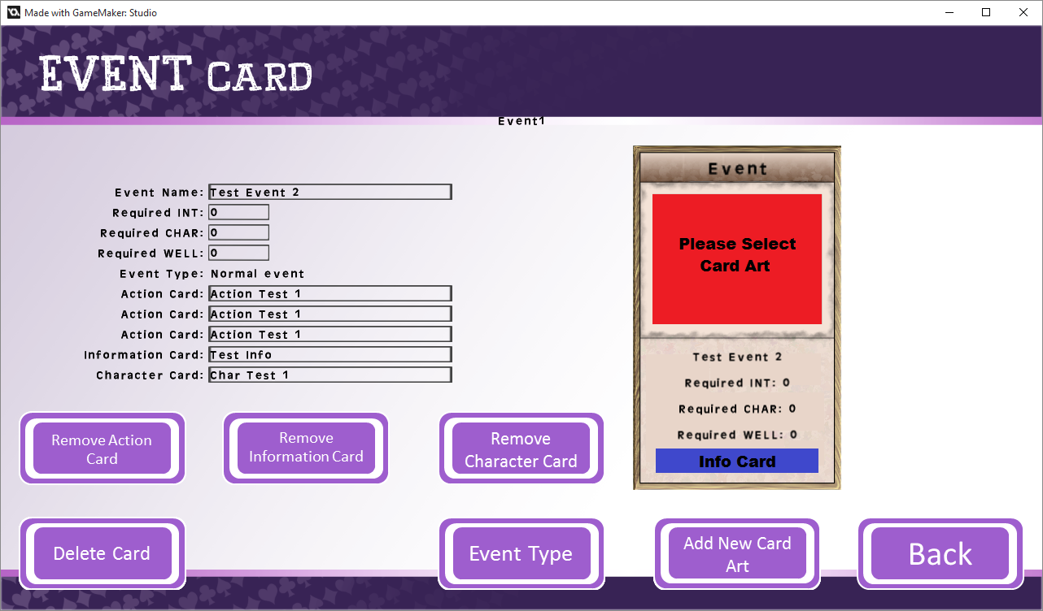

2a.

2b.

1a.

1b.

3a.

4a.

5a.

6a.

4b.

5b.

6b.

7.

3b.

8a.

8b.

## Action

### Controls

* Left Click – Select/Accept

### Screen Layout

1. Consequence Card
   1. Card slot – Clicking the slot will allow you to add a Consequence Card to the Action Card. This is required for every Action.
   2. Remove Card button – Removes the Consequence from the Action Card.
2. Information Card
   1. Card slot – Clicking the slot will allow you to add an Information Card to the Action Card. This is recommended for every Card.
   2. Remove Card button – Removes the Information from the Action Card.

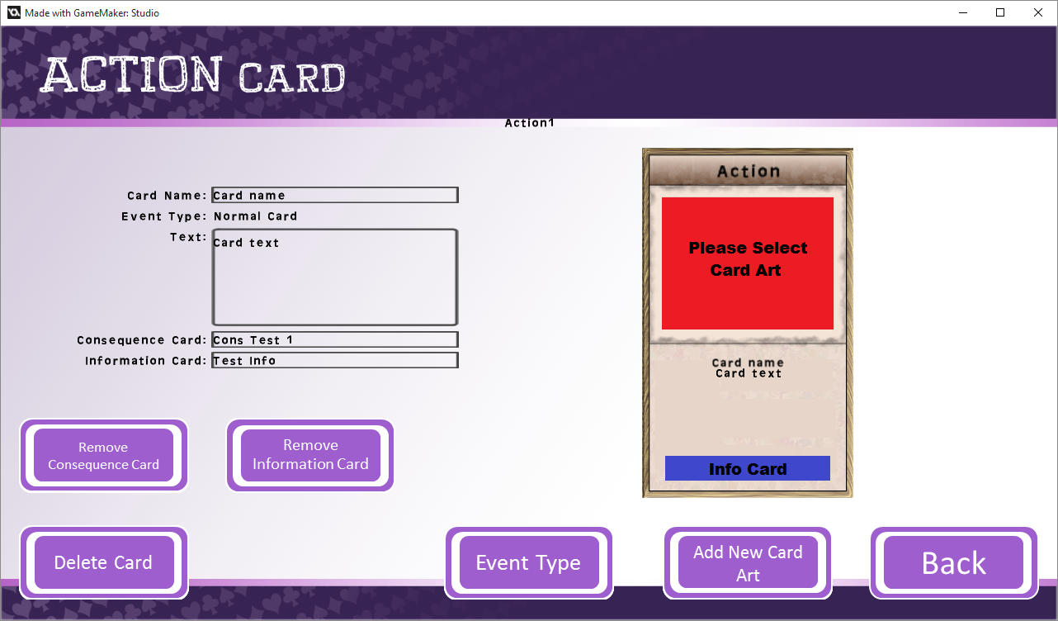

2a.

1b.

2b

1a.

## Consequence

### Controls

* Left Click – Select/Accept

### Screen Layout

1. On consequence Cards, you can set a value to be given (or taken) from the player, using the example below, the card is currently giving 1 to all stats. You can use the buttons to the right of each stat (Minus symbol) to change the value between positive (giving stat increase) or negative (giving stat decrease).

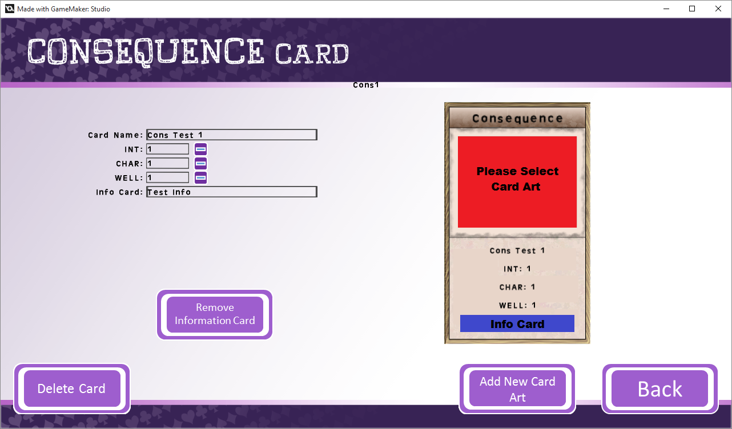

1.

## Information

### Controls

* Left Click – Select/Accept

### Screen Layout

1. On Information Cards, you can enter a web address to provide further information, the player will then be able to click the link and go to the web address.

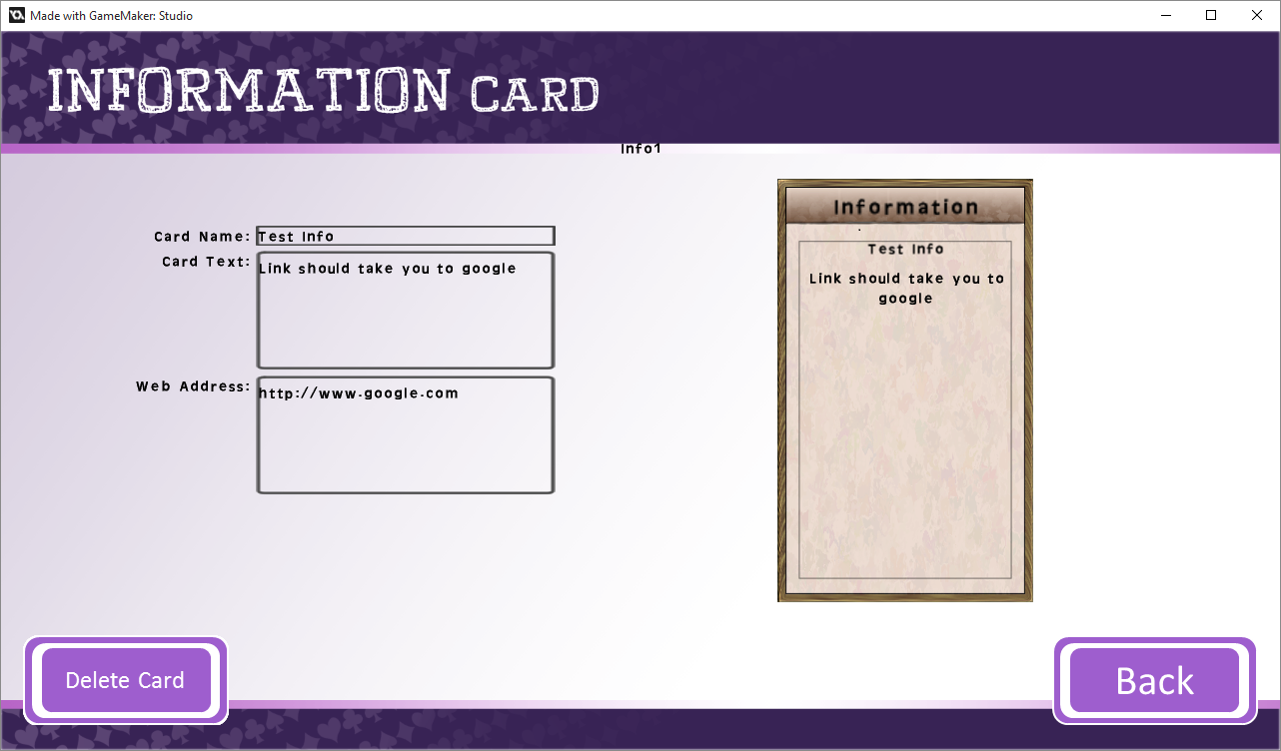

1.

## Character

## Information

### Controls

* Left Click – Select/Accept

### Screen Layout

1. Hopefully by now you have an understanding of each page, there are no special requirements for characters, only a name, description and an Information Card is required.

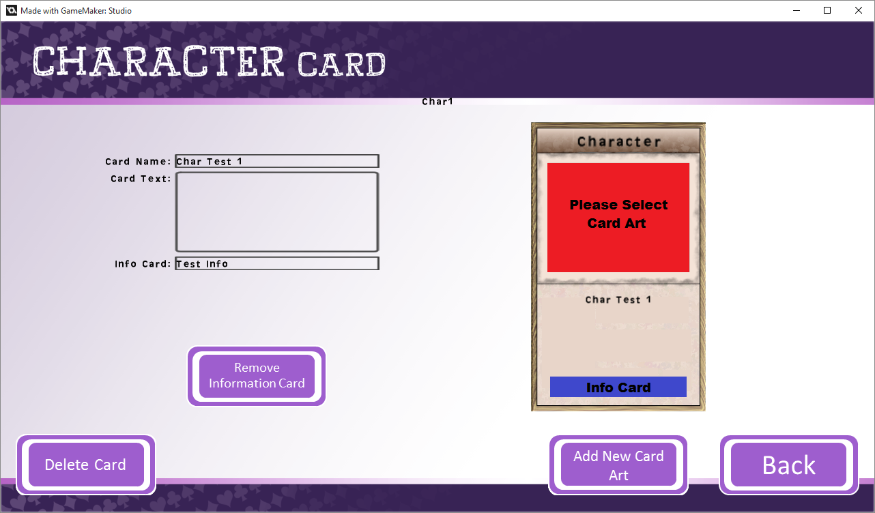

# Image Management

## Information

### Controls

* Left Click – Select/Accept

### Screen Layout

1. Card Type – Selecting this will open a drop down window, in this window it allows you to select each card type to enable you to view each type of Card Art previously added
2. Card Art
   1. The Current Card Art – Arrows will be available when you have multiple and wish to cycle through, you cannot delete the default Card Art.
   2. Add new Card Art – Allows you to add new Card Art (204x160), follow the prompts after clicking the button.
   3. Delete Card Art – Deletes the currently selected Card Art.
3. Card Backing
   1. Current Card Backing
   2. Add Card Background - Allows you to add new Mythical/Regular Card Backing that will replace the default.
   3. Delete Card Background – Deletes the uploaded Card Background returning to default.
4. Building Image
   1. Allows you to view all uploaded Building Images, arrows will appear allowing you to cycle through multiple images.
   2. Add Building Image – Adds a new building image (128x128), follow prompts after clicking button.
   3. Deletes Building Image – Deletes the currently selected Building Image.

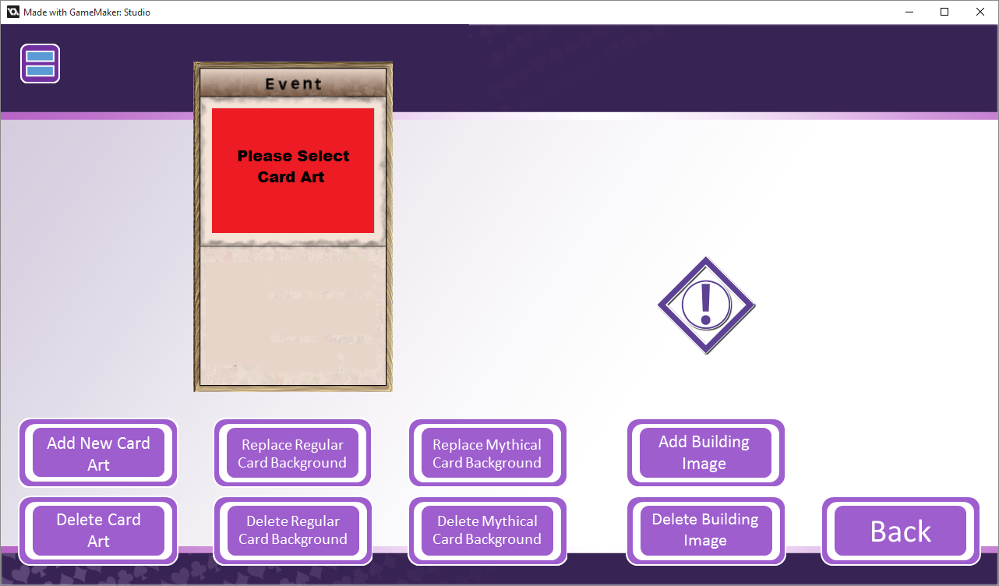

3b.

4c.

4b.

4a.

3c.

3a.

2b.

2a.

2c.

1.

# Background Setup

## Information

### Controls

* Left Click – Select/Accept

### Screen Layout

1. Add Background
   1. Add Background – Adds a background to the current screen. Backgrounds can only be 1920x1080 or 1280x720.
   2. For Location backgrounds, it will upload them to a list, you can use the arrows here to view all the Uploaded Location Backgrounds.
   3. Delete Background – After uploading a background, you are able to delete it using this button.
2. These buttons move you to the selected screen and allow you to change the Background, it works the same as displayed here but you are unable to upload multiple to other screens.
   1. As a side note, Splash Screen and Cards Screen require multiple screens (for each type, Splash: Click and Tap, Cards: One for each type).

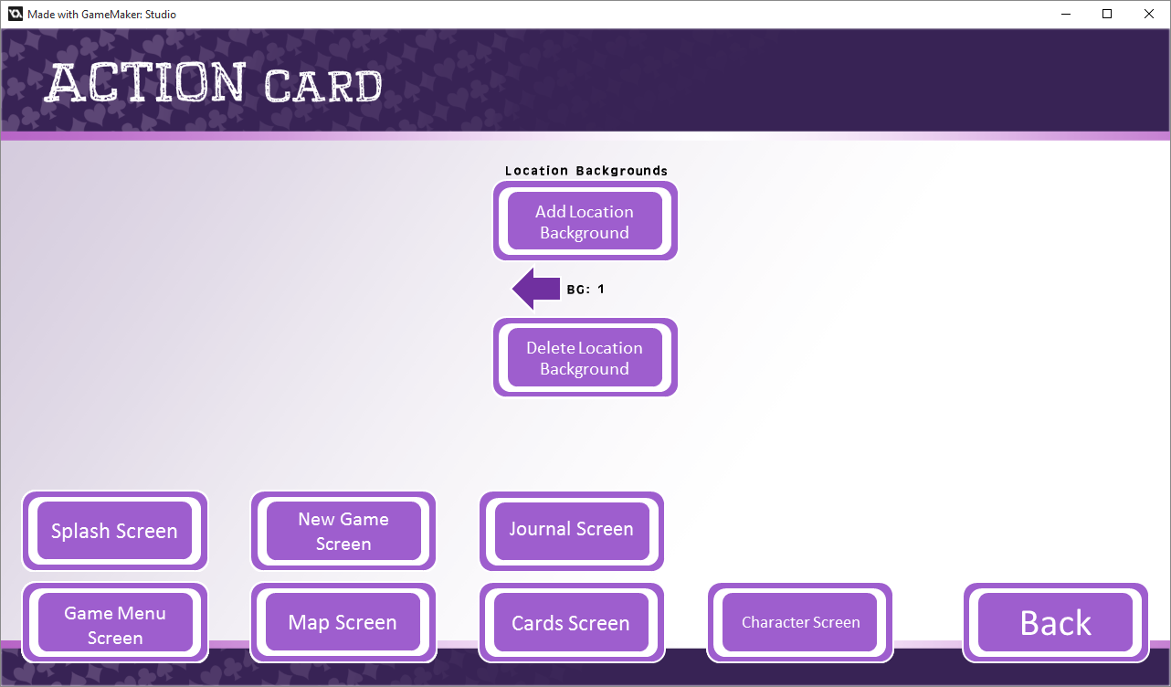

1c.

2.

1b.

1a.

# Tutorial Setup

## Information

### Controls

* Left Click – Select/Accept

### Screen Layout

1. This is a list of tutorials that the player will be given when first playing the game. Some tutorials are locked, as Mythical Cards/Events and Character Cards are not required to be added, you can click those which are included to un-include them.
2. If you click on the arrows next to the tutorials, you can visit the default tutorial Locations/Cards and edit their information as you wish.

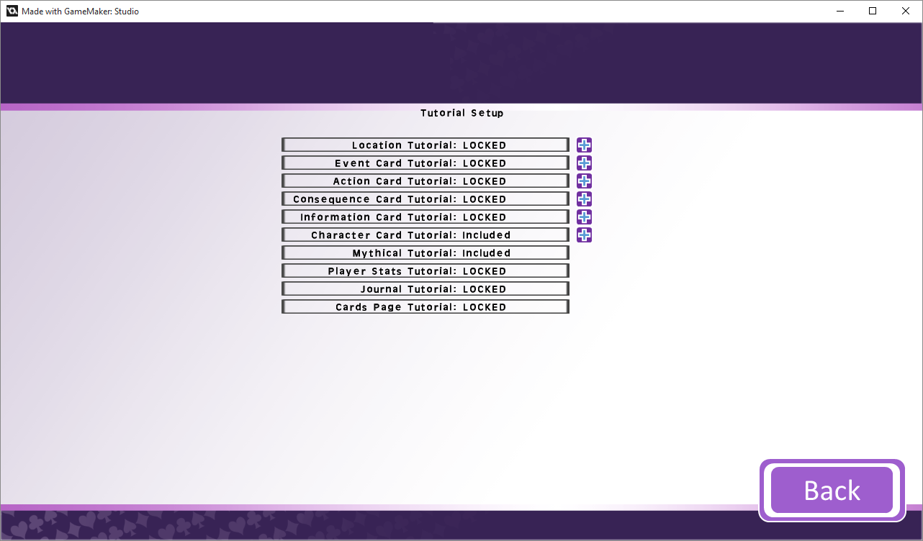

2.

1.

# Options

## Information

### Controls

* Left Click – Select/Accept

### Screen Layout

1. Push Update - If you need to make any changes after pushing the Game to Client, you can use this button to increase the version, this will flag the Client version and download any updates.
2. Custom Stat Names – This will open the custom stats page, see below.
3. Toggle Full-Screen – This will swap between full screen and non-full screen.
4. Reset Window Size - This will reset the window to the default size.
5. Credits – Will open the credits page.

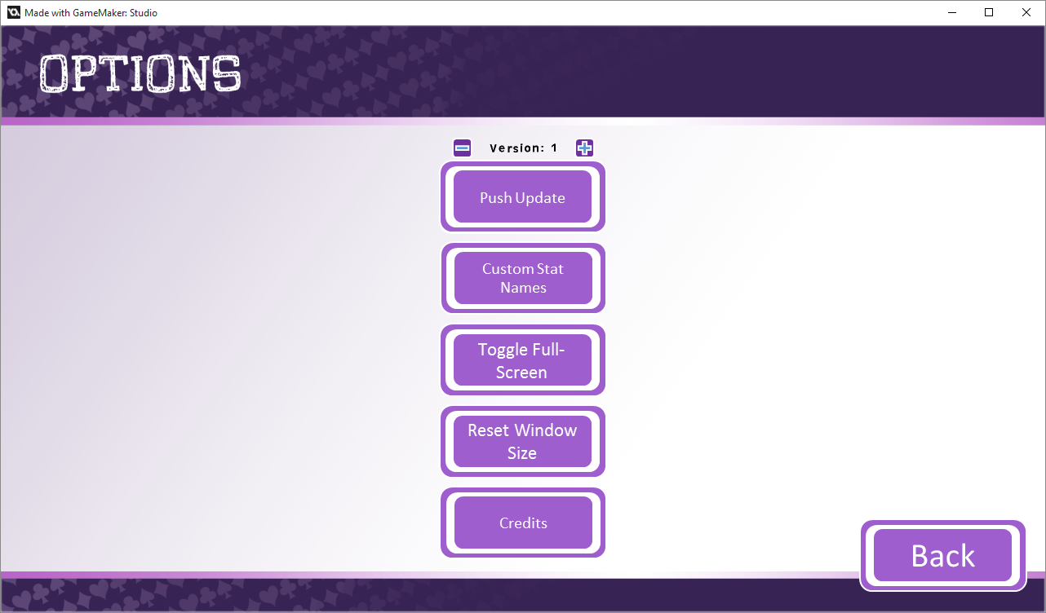

5.

4.

3.

2.

1.

# Custom Stats

## Information

### Controls

* Left Click – Select/Accept

### Screen Layout

1. You can change the Names of stats throughout the game if required, simply type the new name into each box.
2. You can change the amount of weeks available here, by default it will be 24 (number of term weeks).

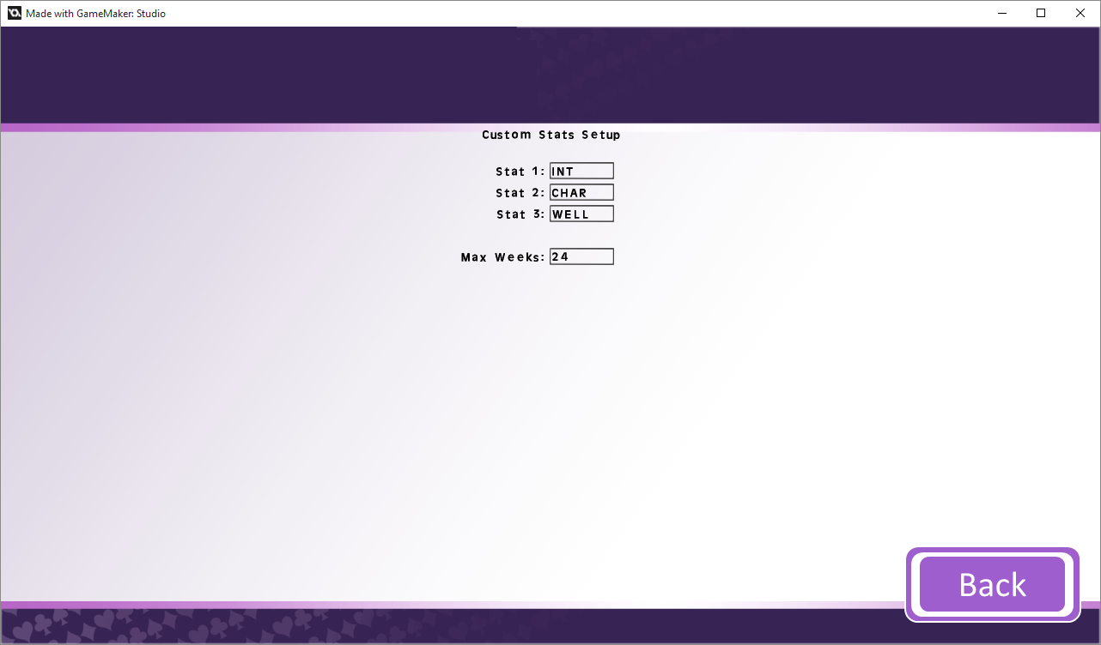

1.

2.